# Statistics Review Problem Set 1

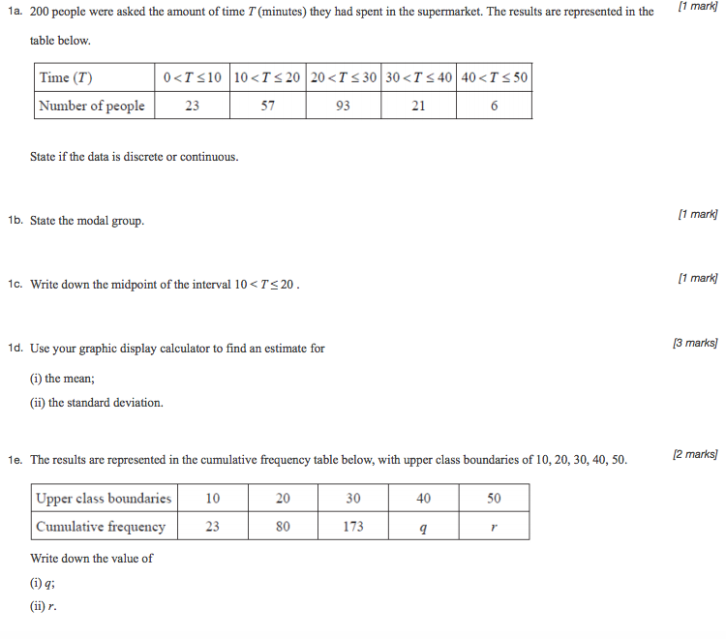

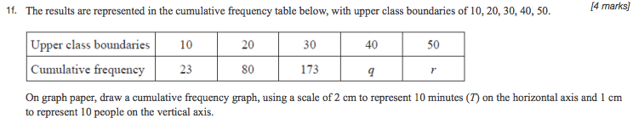

On the graph paper below, draw a cumulative frequency graph for the table above.

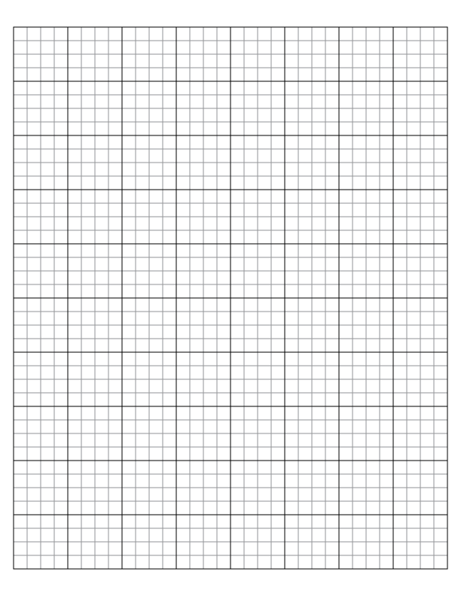

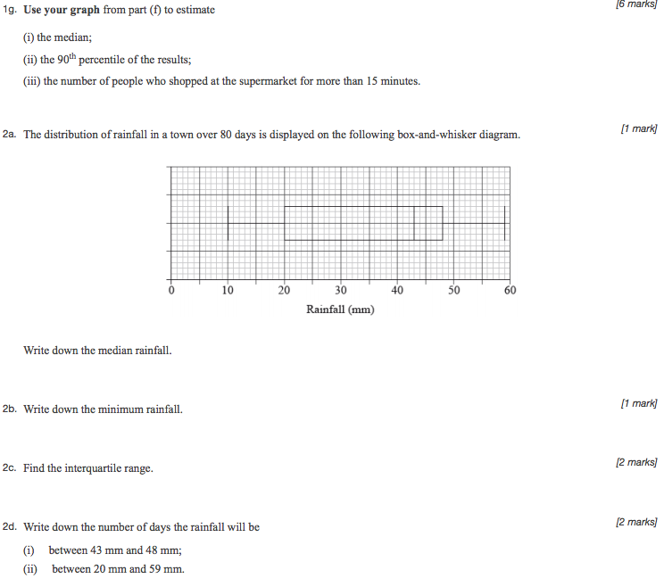



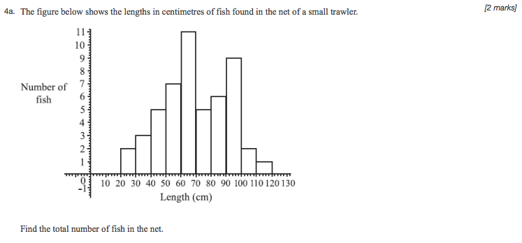

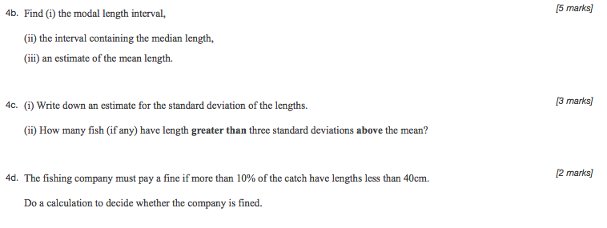



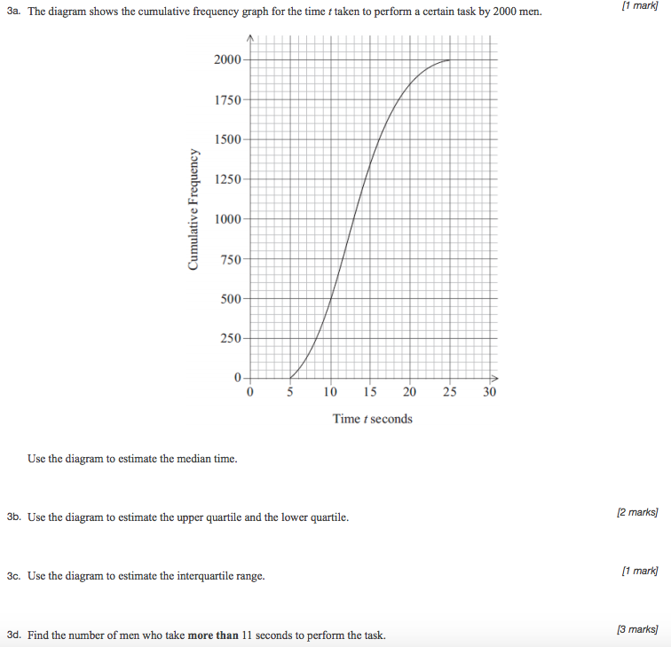

Screen%20Shot%202016-10-27%20at%2011.49.34%20PM.png

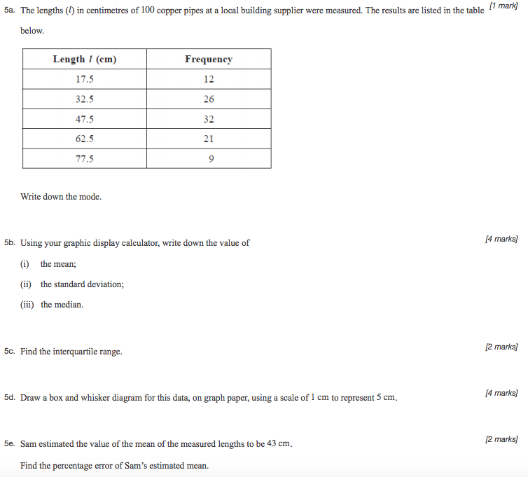

5d. Draw a box and whisker diagram for this data on the graph below. *[4 marks]*



**Statistics Review Problem Set 2**

**1a.** *[3 marks]*

The time, in minutes, that students in a school spend on their homework per day is presented in the following box-and-whisker diagram.  
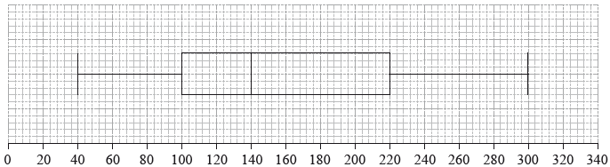

*Time, in minutes, students spend on their homework per day*

Find

(i) the longest amount of time spent on homework per day;

(ii) the interquartile range.

|  |
| --- |
|  |

**1b.** *[1 mark]*

State the statistical term corresponding to the value of 140 minutes.

|  |
| --- |
|  |

**1c.** *[2 marks]*

Find the percentage of students who spend

(i) between 100 and 140 minutes per day on their homework;

(ii) more than 100 minutes per day on their homework.

|  |
| --- |
|  |

**2a.** *[1 mark]*

In a particular week, the number of eggs laid by each hen on a farm was counted. The results are summarized in the following table.

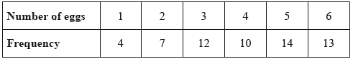

State whether these data are discrete or continuous.

|  |
| --- |
|  |

**2b.** *[2 marks]*

Write down

(i) the number of hens on the farm;

(ii) the modal number of eggs laid.

|  |
| --- |
|  |

**2c.** *[3 marks]*

Calculate

(i) the mean number of eggs laid;

(ii) the standard deviation.

|  |
| --- |
|  |

**3a.** *[1 mark]*

The cumulative frequency graph represents the speed, *s*, in , of 80 cars passing a speed camera.

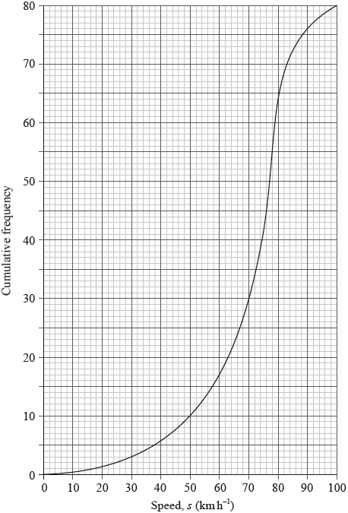

Write down the number of cars passing the camera with speed of less than or equal to 50 .

|  |
| --- |
|  |

**3b.** *[1 mark]*

Complete the following grouped frequency table for , the speed of the cars passing the camera.  
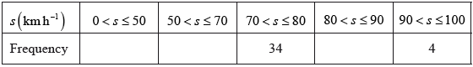

**3c.** *[1 mark]*

Write down the mid-interval value of the  interval.

|  |
| --- |
|  |

**3d.** *[3 marks]*

Use your graphic display calculator to find an estimate of

(i) the mean speed of the cars passing the camera;

(ii) the standard deviation of the speed of the cars passing the camera.

|  |
| --- |
|  |

**4a.** *[2 marks]*

The cumulative frequency graph shows the speed, , in , of  vehicles passing a hospital gate.

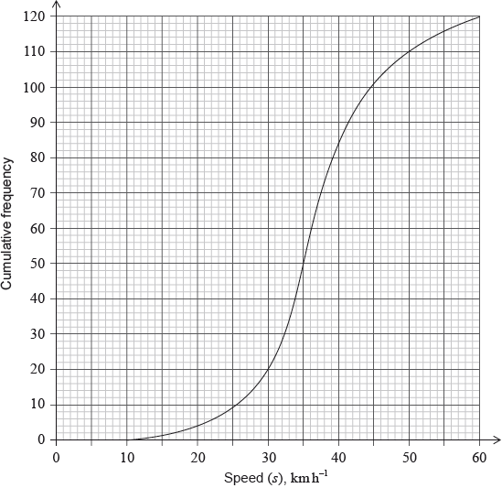

The table shows the speeds of these vehicles travelling past the hospital gate.

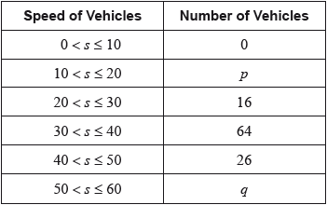

Find the value of  and of .

|  |
| --- |
|  |

**4b.** *[2 marks]*

The table shows the speeds of these vehicles travelling past the hospital gate.



(i) Write down the modal class.

(ii) Write down the mid-interval value for this class.

|  |
| --- |
|  |

**4c.** Use your graphic display calculator to calculate an estimate of

(i) the mean speed of these vehicles;

(ii) the standard deviation. *[3 marks]*

|  |
| --- |
|  |

**4d.** *[2 marks]*

It is proposed that the speed limit past the hospital gate is reduced to  from the current .

Find the percentage of these vehicles passing the hospital gate that **do not** exceed the current speed limit but **would** exceed the new speed limit.

|  |
| --- |
|  |

**4e.** The cumulative frequency graph shows the speed, , in , of  vehicles passing a hospital gate.



Estimate the minimum possible speed of one of these vehicles passing the hospital gate. *[1 mark]*

**4f.** Find the median speed of the vehicles. *[2 marks]*

**4g.** Write down the  percentile. *[1 mark]*

**4h.** Calculate the interquartile range. *[2 marks]*

**4i.** The speed limit past the hospital gate is .

Find the number of these vehicles that exceed the speed limit. *[2 marks]*

**5a.** *[1 mark]*

The distribution of rainfall in a town over 80 days is displayed on the following box-and-whisker diagram.  
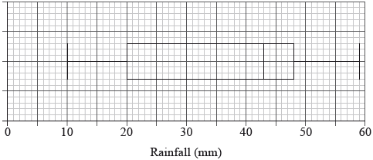

Write down the median rainfall.

|  |
| --- |
|  |

**5b.** *[1 mark]*

Write down the minimum rainfall.

|  |
| --- |
|  |

**5c.** *[2 marks]*

Find the interquartile range.

|  |
| --- |
|  |

**5d.** *[2 marks]*

Write down the number of days the rainfall will be

(i) between 43 mm and 48 mm;

(ii) between 20 mm and 59 mm.

|  |
| --- |
|  |

# Statistics Review Problem Set 3

**6a.** *[3 marks]*

A class of 15 students were asked how many pencils they bring to class. The following results were recorded:



For these results, write down

(i) the median;

(ii) the mode.

|  |
| --- |
|  |

**6b.** *[3 marks]*

The upper and lower quartiles of these results are  and , respectively.

Draw a box-and-whisker diagram to represent these results.

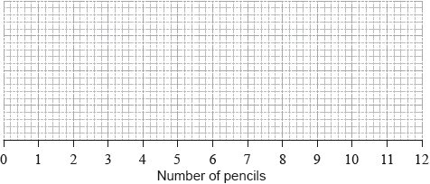

**7a.** *[2 marks]*

The IB grades attained by a group of students are listed as follows.



Find the median grade.

|  |
| --- |
|  |

**7b.** *[2 marks]*

Calculate the interquartile range.

|  |
| --- |
|  |

**7c.** *[2 marks]*

Find the probability that a student chosen at random from the group scored at least a grade .

|  |
| --- |
|  |

**8a.** Two groups of 40 students were asked how many books they have read in the last two months. The results for **the first group** are shown in the following table.

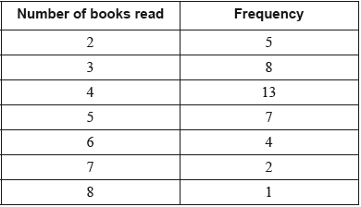

The quartiles for these results are 3 and 5.

Write down the value of the median for these results. *[1 mark]*

**8b.** Draw a box-and-whisker diagram for these results on the following grid. *[3 marks]*

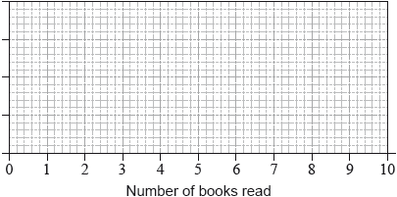

**8c.** The results for **the second group** of 40 students are shown in the following box-and-whisker diagram.

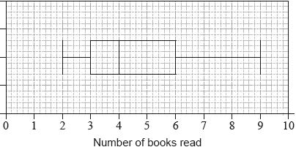

Estimate the number of students **in the second group** who have read at least 6 books. *[2 marks]*

**9a.** *[1 mark]*

A class of 13 Mathematics students received the following grades in their final IB examination.

3 5 3 4 7 3 2 7 5 6 5 3 4

For these grades, find the mode;

|  |
| --- |
|  |

**9b.** *[2 marks]*

For these grades, find the median;

|  |
| --- |
|  |

**9c.** *[1 mark]*

For these grades, find the upper quartile;

|  |
| --- |
|  |

**9d.** *[2 marks]*

For these grades, find the interquartile range.

|  |
| --- |
|  |

# Statistics Review Problem Set 4

**1a.** *[3 marks]*

The Brahma chicken produces eggs with weights in grams that are normally distributed about a mean of 55 g with a standard deviation of 7 g. The eggs are classified as small, medium, large or extra large according to their weight, as shown in the table below.

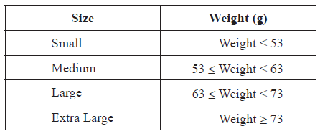

Sketch a diagram of the distribution of the weight of Brahma chicken eggs. On your diagram, show clearly the boundaries for the classification of the eggs.

**1b.** *[4 marks]*

An egg is chosen at random. Find the probability that the egg is

1. medium
2. extra large.

**1c.** *[2 marks]*

There is a probability of  that a randomly chosen egg weighs more than  grams.

Find  .

**1d.** *[2 marks]*

The probability that a Brahma chicken produces a large size egg is . Frank’s Brahma chickens produce  eggs each month.

Calculate an estimate of the number of large size eggs produced by Frank’s chickens each month.

**1e.** *[3 marks]*

The selling price, in US dollars (USD), of each size is shown in the table below.

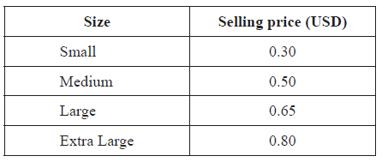

The probability that a Brahma chicken produces a small size egg is .

Estimate the monthly income, in USD, earned by selling the  eggs. Give your answer correct to two decimal places.

**2a.** *[2 marks]*

A group of candidates sat a Chemistry examination and a Physics examination. The candidates’ marks in the Chemistry examination are normally distributed with a mean of 60 and a standard deviation of 12. Draw a diagram that shows this information.

**2b.** *[1 mark]*

Write down the probability that a randomly chosen candidate who sat the Chemistry examination scored at most 60 marks.

**2c.** *[2 marks]*

Hee Jin scored 80 marks in the Chemistry examination. Find the probability that a randomly chosen candidate who sat the Chemistry examination scored **more** than Hee Jin.

**2d.** *[2 marks]*

The candidates’ marks in the Physics examination are normally distributed with a mean of  and a standard deviation of . Hee Jin also scored  marks in the Physics examination. Find the probability that a randomly chosen candidate who sat the Physics examination scored **less** than Hee Jin.

**2e.** *[2 marks]*

Determine whether Hee Jin’s Physics mark, **compared to the other candidates**, is better than her mark in Chemistry. Give a reason for your answer.

**2f.** *[3 marks]*

To obtain a “grade A” a candidate must be in the top  of the candidates who sat the Physics examination.

Find the minimum possible mark to obtain a “grade A”. Give your answer correct to the nearest integer.

**3a.** *[2 marks]*

The daily January temperature of Cairns is normally distributed with a mean of 34°C and a standard deviation of 3. Calculate the probability that the temperature on a randomly chosen day in January is less than 39°C.

**3b.** *[2 marks]*

Calculate the expected number of days in January that the temperature will be more than 39°C.

**3c.** *[2 marks]*

On a randomly chosen day in January, the probability that the temperature is above  °C is 0.7.

Find the value of .

**4a.** *[2 marks]*

Consider the following values of x and y and the scatter diagram which represents the information given in the table.

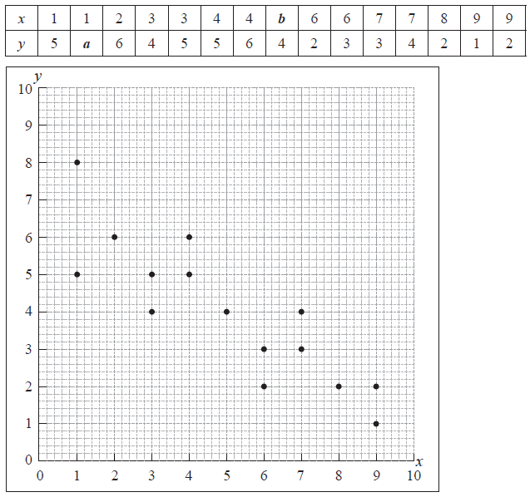

Write down the value of

(i) a ;

(ii) b .

**4b.** *[2 marks]*

State the type of correlation and the strength of the relationship.

**5a.** Francesca is a chef in a restaurant. She cooks eight chickens and records their masses and cooking times. The mass *m* of each chicken, in kg, and its cooking time *t*, in minutes, are shown in the following table. *[4 marks]*

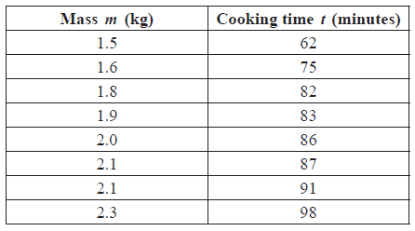

Draw a scatter diagram to show the relationship between the mass of a chicken and its cooking time. Use 2 cm to represent 0.5 kg on the horizontal axis and 1 cm to represent 10 minutes on the vertical axis.

**5b.** *[2 marks]*

Write down for this set of data

1. the mean mass, m;
2. the mean cooking time, t.

**5c.** *[1 marks]*

Label the point M(m,t) on the scatter diagram.